--=================================================================================

--=============================== CIS 310 Exercise 1 ===============================

--=================================================================================

/\*

STUDENT NAME: Jacob Palmer

STUDENT ID: 5262256

SUBMISSION DATE: 1/9/2024

\*/

1. Do you spot any data redundancies in given data table? If so, what are the redundancies?
2. Explain the 3 types of data anomalies using below table. Update, Insertion, and Deletion.  
   -- Your explanation should refer to specific data as shown. Such as “ When Project manager is…….It causes…..”

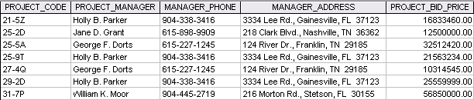

1. Data Redundancy:

Project Manager “Holly B. Parker” ‘s Manager Phone, Manager Address, and Project Bid Price data is listed three separate times, as well as two separate times for Project Manager “George F. Dorts.” In both cases, each redundant row has a different Project Code

2a. Update Anomaly:

When Holly B. Parker changes their phone number to 904-338-3457, because her data is stored three separate times, only one of the phone numbers will be updated to the proper value while the other two still keep the original.

2b. Insertion Anomaly:

When a new manager joins the company, a non-null value must be input for the Project Code. If, for example, John B. Doe were to join without a Project Code, then we would not be able to insert him fully due to the absence of additional data that must be filled in.

2c. Deletion Anomaly:

When a project bid price is resolved corresponding to Jane D. Grant, deleting that data would also delete the rest of Grant’s information- including project code, manager phone and address, and the name.